Assignment 4: Security Concepts
and the Fast Gradient Sign Method
CSC 592: Machine Learning Security and Privacy

Part 1: Security and Machine Learning Concepts

Q1. A feedforward neural network with ReLU activation functions is trained on the following input image:
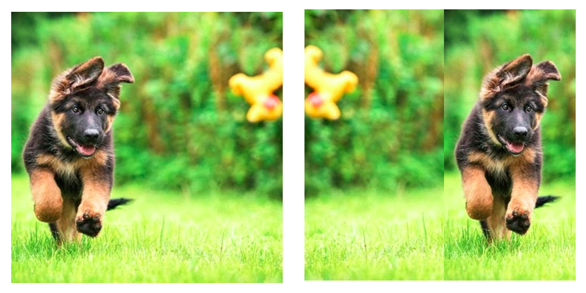
Training Image
Testing Image
The network operates on 2D input images by flattening them to 1D and then processing the 1D tensor. After training, would it be likely or unlikely that the feedforward neural network would correctly recognize the test image? Would your answer change if the network took 2D input and used convolution and pooling layers?
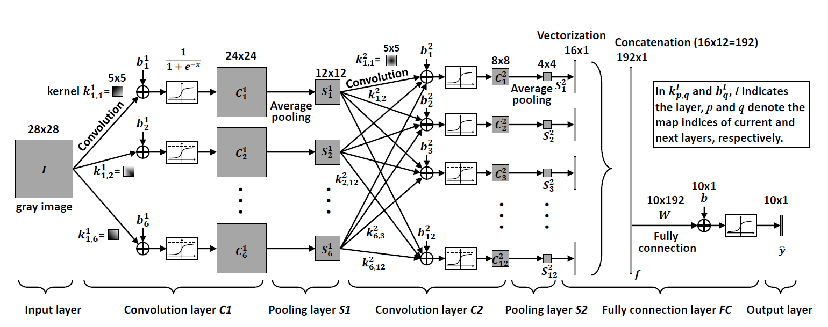Q2: Consider the following part of the CNN architecture shown above. How many trainable parameters are in this part of the architecture? Show all calculations used to derive your answer.
Q3. Images are typically input into CNNs for classification. Each image is comprised of pixels. For RGB images, each pixel has three color channels. Each channel has an integer value ranging from 0-255. When loaded into PyTorch, the pixel values are further converted into a decimal ranging from 0-1. Assuming that the pixels start in the 0-1 range in the following code snippet, consider the associated transformations for the dataloader shown below:
from torchvision import transforms
image_transforms = {
"train": transforms.Compose([
transforms.Resize((224, 224)),
transforms.ToTensor(),
transforms.Normalize([0.5, 0.5, 0.5],
[0.5, 0.5, 0.5])
]),
"test": transforms.Compose([
transforms.Resize((224, 224)),
transforms.ToTensor(),
transforms.Normalize([0.5, 0.5, 0.5],
[0.5, 0.5, 0.5])
])
}
Part A: Based on the above code snippet, what is the maximum value any pixel color channel can have after the transformations are applied? What is the minimum value any pixel color channel can have after the transformations are applied?
Hint: You may want to read the PyTorch documentation for how normalization transforms are handled here: https://discuss.pytorch.org/t/understanding-transform-normalize/21730
Part B: Assuming that the pixels start in the 0-1 range in the following code snippet, consider the associated transformations for the dataloader:
from torchvision import transforms
image_transforms = {
"train": transforms.Compose([
transforms.Resize((224, 224)),
transforms.ToTensor(),
transforms.Normalize([0.0, 0.0, 0.0],
[1.0, 1.0, 1.0])
]),
"test": transforms.Compose([
transforms.Resize((224, 224)),
transforms.ToTensor(),
transforms.Normalize([0.0, 0.0, 0.0],
[1.0, 1.0, 1.0])
])
}
Based on the above code snippet, what is the maximum value any pixel color channel can have after the transformations are applied? What is the minimum value any pixel color channel can have after the transformations are applied?
Q4. Assuming that the pixels start in the 0-1 range in the following code snippet, consider the associated transformations for the dataloader:
from torchvision import transforms
image_transforms = {
"train": transforms.Compose([
transforms.Resize((224, 224)),
transforms.ToTensor(),
transforms.Normalize([0.49139968, 0.48215827, 0.44653124],
[0.24703233, 0.24348505, 0.26158768])
])
}
Part A: Based on the above code snippet, what is the maximum value each of the RED, GREEN and BLUE pixel color channels can have after the transformations are applied? What is the minimum value each of the RED, GREEN and BLUE pixel color channels can have after the transformations are applied?
Part B: Consider a model trained with a training dataloader with the transformations given in Q4. Part A. We then separately create a test dataloader with the following transformations:
from torchvision import transforms
image_transforms_test = {
"test": transforms.Compose([
transforms.Resize((224, 224)),
transforms.ToTensor(),
transforms.Normalize([0.0, 0.0, 0.0],
[1.0, 1.0, 1.0])
])
}
Would you expect the model to perform well on the test data in this scenario? Explain why or why not?
Q5. In security the first step in modeling a security problem is often to define an adversarial threat model. The adversarial threat model explicitly states what capabilities the attacker has. In security we strive to make the adversarial threat model realistic and practical. For example, for a thief trying to steal valuable items from your house, it might be realistic for them to own a hammer to break the windows of your house. However, it would not be realistic for the thieves to have access to an intercontinental ballistic missile to destroy your windows. For a thief trying to break into your home to steal valuable items, list 5 realistic tools or capabilities they might have?
Q6. In question 5, it is obvious the attacker (the thief) succeeds if they manage to steal valuable items from your home. Consider each of the following more ambiguous computer security scenarios and write down what might be considered a successful attack?
Part A: An attacker gets a list of all the university emails and sends out a mass email to every student.
Part B: An attacker puts a malicious file on a website. If you download the file, a program runs that encrypts all your personal files. Only the attacker knows the key to decrypt the data.
Part C: A new election system is being developed that allows you to vote online electronically. The current system is setup so that you can submit an electronic ballot after submitting a picture of your license. How might the system be attacked?
Part 2: The Fast Gradient Sign Method Code

Background

Evasion attacks pose significant threats in machine learning applications where security, safety, and reliability are paramount. These attacks involve creating adversarial examples from clean input data. In evasion attacks input data is subtly altered, this makes machine learning models give incorrect predictions or classifications. Evasion attacks can lead to severe consequences in domains such as autonomous driving, healthcare, and financial fraud detection where misclassification can result in accidents, misdiagnoses, or financial losses.
The Fast Gradient Sign Method (FGSM) is one of the simplest evasion attacks in adversarial machine learning. FGSM is designed to generate adversarial examples by exploiting the gradients of a target model. Introduced in an e-print (https://arxiv.org/abs/1412.6572) by Ian Goodfellow et al. in 2014, the original FGSM work has been cited over 29,000 times since 2026. For context, that number of citations is approximately equivalent to 29 Professor Kaleels.
In this part you will get familiar with the FGSM attack code and its input parameters.
Step by Step Guide
Follow the instructions carefully step by step:
Step 1: Create a new Python project called “FGSMLab” using the Integrated Development Environment (IDE) of your choice (e.g., Visual Studio, Visual Studio Code, PyCharm).
Step 2: Download and add three .py source files from Brightspace to your “FGSMLab” Python project. The three source files are, “AttackWrappersWhiteBox.py”, “ResNet.py” and “DataManagerPytorchL.py”. Your project should contain the following files as shown in the screenshot below:
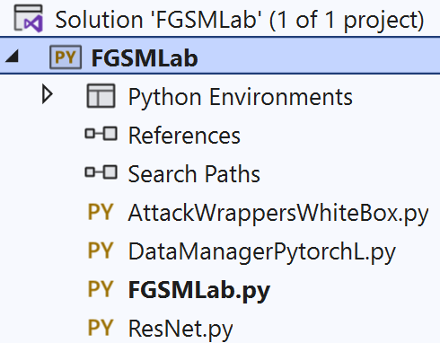
Step 3: Download the machine learning model we will be attacking from Brightspace. The model file is called “ModelResNet56-Run0.th”. Copy the file path of where the model is saved, as we will need it later. In Windows you can do this by right clicking on the model file, selecting properties, and then copying the value of the Location property. This is shown in the screenshot below:
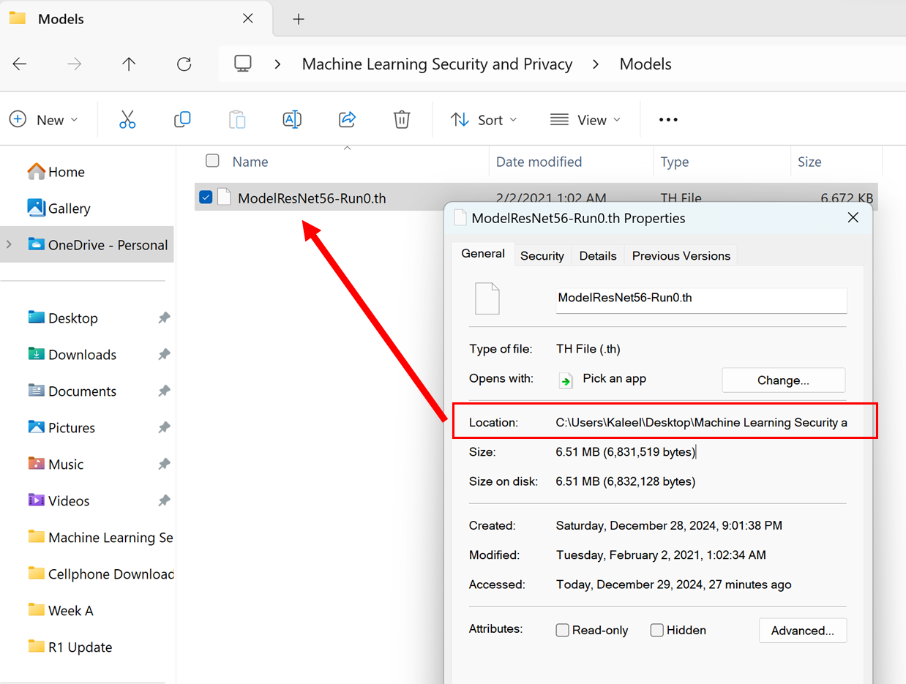
Step 4: Go to the FGSMLab.py file and copy the following code:
import torch
import DataManagerPytorchL as DMP
import AttackWrappersWhiteBox
import ResNet

def main():
#Replace the next line with the file path of where you saved the ResNet model
modelDir = "C://Users//Kaleel//Desktop//Machine Learning Security and Privacy//Models//ModelResNet56-Run0.th"
#Define the GPU device we are using
device = torch.device("cuda")
#Parameters for the dataset
batchSize = 64
numClasses = 10
inputImageSize = [1, 3, 32, 32] #Batch size, color channel, height, width
#Create the ResNet model (note this does not include pre-trained weights)
model = ResNet.resnet56(inputImageSize, numClasses).to(device)
#Next load in the trained weights of the model
checkpoint = torch.load(modelDir)
model.load_state_dict(checkpoint['state_dict'])
#Switch the model into eval model for testing
model = model.eval()

Step 5: Recall that in step 3 you were asked to note down the file path of where you saved “ModelResNet56-Run0.th”. In the main function, replace the modelDir value with the file path where you saved “ModelResNet56-Run0.th”. For me the file path looked like:
C://Users//Kaleel//Desktop//Machine Learning Security and Privacy//Models//ModelResNet56-Run0.th
Step 6: Test the code by adding the following lines below def main() without indentation.
if __name__ == "__main__":
main()
Then run the FGSMLab.py code and verify that no errors are reported when loading the model.

Step 7: The “ModelResNet56-Run0.th” is a convolutional neural network that has been trained on the CIFAR-10 dataset. The first verification check you should do when working with a pre-trained model is to make sure that the model accuracy matches what has been reported online or in the literature. To do this, add the following code after the last line in main function (highlighted below):
def main():
#Replace the next line with the file path of where you saved the ResNet model
modelDir = "C://Users//Kaleel//Desktop//Machine Learning Security and Privacy//Models//ModelResNet56-Run0.th"
#Define the GPU device we are using
device = torch.device("cuda")
#Parameters for the dataset
batchSize = 64
numClasses = 10
inputImageSize = [1, 3, 32, 32] #Batch size, color channel, height, width
#Create the ResNet model (note this does not include pre-trained weights)
model = ResNet.resnet56(inputImageSize, numClasses).to(device)
#Next load in the trained weights of the model
checkpoint = torch.load(modelDir)
model.load_state_dict(checkpoint['state_dict'])
#Switch the model into eval model for testing
model = model.eval()
#Load in the dataset
valLoader = DMP.GetCIFAR10Validation(inputImageSize[2], batchSize)
#Check the clean accuracy of the model
cleanAcc = DMP.validateD(valLoader, model, device)
print("CIFAR-10 Clean Val Loader Acc:", cleanAcc)

Step 8: Run the FGSMLab.py code and check what clean accuracy is reported. You should get 0.9277
Step 9: Typically, adversarial attacks are created from examples that the model can correctly classify. To understand how accurate a model is at classifying adversarial examples, we will work with 100 examples that are correctly identified and class wise balanced. Add the following code to the main function as highlighted below:
def main():
#Replace the next line with the file path of where you saved the ResNet model
modelDir = "C://Users//Kaleel//Desktop//Machine Learning Security and Privacy//Models//ModelResNet56-Run0.th"
#Define the GPU device we are using
device = torch.device("cuda")
#Parameters for the dataset
batchSize = 64
numClasses = 10
inputImageSize = [1, 3, 32, 32] #Batch size, color channel, height, width
#Create the ResNet model (note this does not include pre-trained weights)
model = ResNet.resnet56(inputImageSize, numClasses).to(device)
#Next load in the trained weights of the model
checkpoint = torch.load(modelDir)
model.load_state_dict(checkpoint['state_dict'])
#Switch the model into eval model for testing
model = model.eval()
#Load in the dataset
valLoader = DMP.GetCIFAR10Validation(inputImageSize[2], batchSize)
#Check the clean accuracy of the model
cleanAcc = DMP.validateD(valLoader, model, device)
print("CIFAR-10 Clean Val Loader Acc:", cleanAcc)
#Get correctly classified, classwise balanced samples to do the attack
totalSamplesRequired = 100
correctLoader = DMP.GetCorrectlyIdentifiedSamplesBalanced(model, totalSamplesRequired, valLoader, numClasses)
#Check to make sure the accuracy is 100% on the correct loader
correctAcc = DMP.validateD(correctLoader, model, device)
print("CIFAR-10 Clean Correct Loader Acc:", correctAcc)
Step 10: Run the FGSMLab.py code and check what CIFAR-10 Clean Correct Loader Acc result is reported. You should get 1.0
Step 11: It is finally time to try the FGSM attack. Call the FGSM attack and check the results on the model by adding the following code to the end of the main function as highlighted below:
def main():
#Replace the next line with the file path of where you saved the ResNet model
modelDir = "C://Users//Kaleel//Desktop//Machine Learning Security and Privacy//Models//ModelResNet56-Run0.th"
#Define the GPU device we are using
device = torch.device("cuda")
#Parameters for the dataset
batchSize = 64
numClasses = 10
inputImageSize = [1, 3, 32, 32] #Batch size, color channel, height, width
#Create the ResNet model (note this does not include pre-trained weights)
model = ResNet.resnet56(inputImageSize, numClasses).to(device)
#Next load in the trained weights of the model
checkpoint = torch.load(modelDir)
model.load_state_dict(checkpoint['state_dict'])
#Switch the model into eval model for testing
model = model.eval()
#Load in the dataset
valLoader = DMP.GetCIFAR10Validation(inputImageSize[2], batchSize)
#Check the clean accuracy of the model
cleanAcc = DMP.validateD(valLoader, model, device)
print("CIFAR-10 Clean Val Loader Acc:", cleanAcc)
#Get correctly classified, classwise balanced samples to do the attack
totalSamplesRequired = 100
correctLoader = DMP.GetCorrectlyIdentifiedSamplesBalanced(model, totalSamplesRequired, valLoader, numClasses)
#Check to make sure the accuracy is 100% on the correct loader
correctAcc = DMP.validateD(correctLoader, model, device)
print("CIFAR-10 Clean Correct Loader Acc:", correctAcc)
#Do the FGSM attack
epsilonMax = 0.031 #Maximum perturbation
clipMin = 0.0 #Minimum value a pixel can take
clipMax = 1.0 #Maximum value a pixel can take
advLoader = AttackWrappersWhiteBox.FGSMNativePytorch(device, correctLoader, model, epsilonMax, clipMin, clipMax)
#Check the accuracy of the model on the adversarial examples
advAcc = DMP.validateD(advLoader, model, device)
print("CIFAR-10 FGSM Loader Acc:", advAcc)

Step 12: Run the FGSMLab.py code and check what CIFAR-10 FGSM Loader Acc result you get. If you have followed all steps correctly your code should output the following:
Files already downloaded and verified
CIFAR-10 Clean Val Loader Acc: 0.9277
CIFAR-10 Clean Correct Loader Acc: 1.0
Processing up to sample= 64
Processing up to sample= 100
CIFAR-10 FGSM Loader Acc: 0.25
Step 13: Answer the following questions associated with code.
Q7. Record a screenshot of your code after you have run the FGSM attack in step 12.
Q8. A white-box attack like FGSM requires a loss function $L$ to operate. Generally speaking, it is good coding practice to soft code all inputs to a method. Look at the FGSM attack code in “AttackWrappersWhiteBox.py”. Was the loss function soft coded? If not, what loss function is used in the FGSM code? Copy the line where the loss function is set in the FGSM code?
Q9. Which line of Python code in “AttackWrappersWhiteBox.py” corresponds to the following equation: $x_{adv}=x+ϵ_{max}∙sign\left(\frac{∂L\left(C(x,w)\right)}{∂x}\right)$. Copy the line of code for this equation below?

Q10. What value did we use for $ϵ_{max}$ in the FGSM code? Copy the line of code where we set $ϵ_{max}$?
Deliverables
Submit the following two items on Brightspace:
Deliverable #1: A document (word or pdf) that contains your answers to the 10 assignment questions.
Deliverable #2: A copy of your code (the .py files).

